

SIMATS ENGINEERING
Saveetha Institute of Medical and Technical Sciences
Chennai- 602105

Student Name: TL Bhuvanesh Reg. No.: 192311021

Course Code: CSA1706 Slot : B
Course Name: Microwave engineering for navigation
Course Faculty: Dr.K.Krishna Kumar
Project Title: Smart Setiment Analysis Of Product Reviews
Module Photographs: (2 photographs –Module Photo, Individual student contribution module work in the project and presentation image)
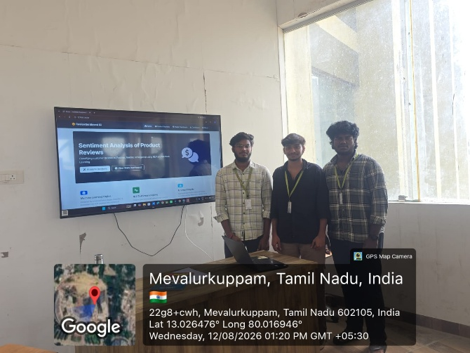
Project Description:
The Smart Setiment Analysis Of Product Reviews : Automation is an advanced security solution designed to detect motion using microwave Doppler radar technology and automatically trigger protective responses. The system operates by transmitting microwave signals and analyzing frequency changes caused by moving objects based on the Doppler Effect. When motion is detected, the sensor sends a signal to a microcontroller, which activates alarms, lights, or notification systems. Unlike traditional PIR sensors, this system functions effectively in complete darkness and is less affected by temperature variations. It offers fast response time and continuous real-time monitoring. The system is designed to minimize false alarms through proper calibration and signal filtering. It is energy-efficient and suitable for long-term operation. The project integrates automation features that enhance overall security performance. It can be applied in homes, offices, warehouses, and restricted areas. Overall, the system provides a reliable, smart, and scalable approach to modern security and surveillance needs.

Student Signature Guide Signature

